# Network Analysis & Synthesis Lab

## (MATLAB Lab Report)

# Group – V (Roll 63-77)

**Team Members**

✓ Sayan Mondal (63)

✓ Abantika Saha (64)

✓ Sayan Das (65)

✓ Raj Suyash Ranjan (66)

✓ Vemula Rahul (67)

✓ Sohini Bhattacharya (68)

✓ Anirban Moi (69)

✓ Kalakonda Dheeraj Reddy ( 70)

✓ Subham Gupta (71)

✓ Tuhin Karak (72)

✓ Souradeepta Pal (73)

✓ Koustav Sanyal (74)

✓ Diksha Senapati (75)

✓ Aman Kumar (76)

✓ Yogeswar Sarnakar (77)

Experiment :1 & 2

TITLE: Transient Response of RC and RL circuit.

OBJECTIVE:

1. Study the transient response of a series RC circuit and understand the time constant concept using pulse waveform.
2. Study the transience due to inductors using a series RL circuit and understand the time constant concept.

SIMULATIONS:

For RC Circuit:

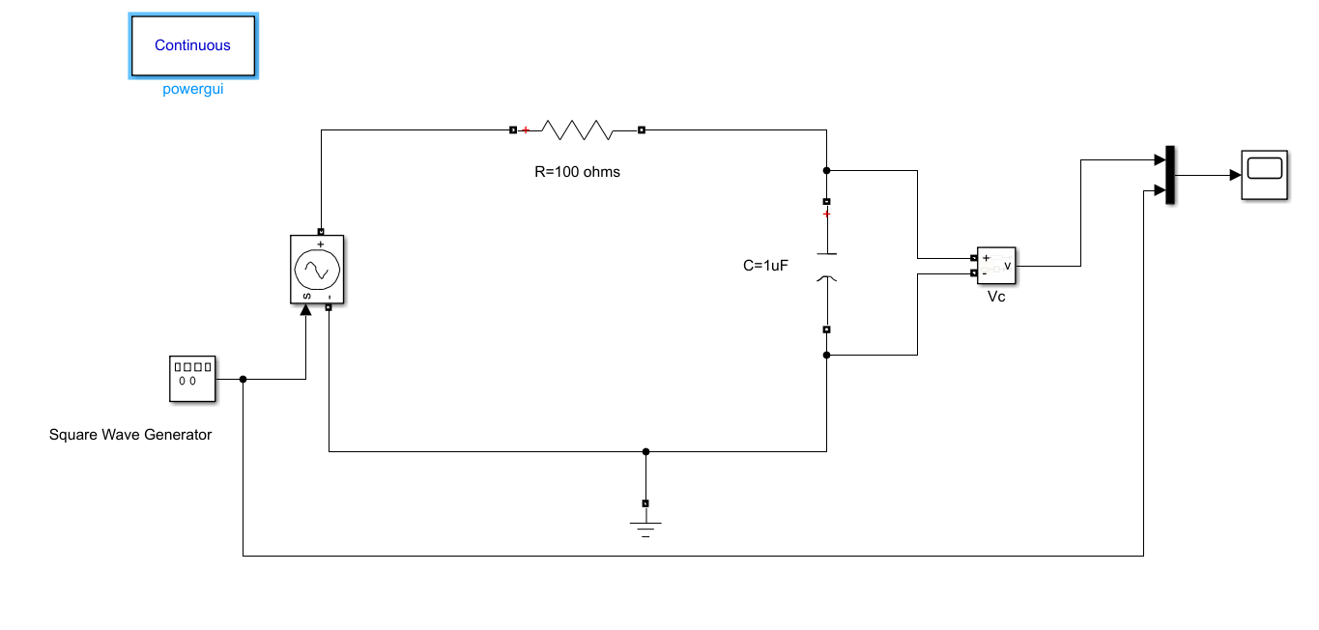

* R = 100 ohms
* C = 1µF
* Time constant (τ) = RC =100×1× = sec
* For RL Circuit:

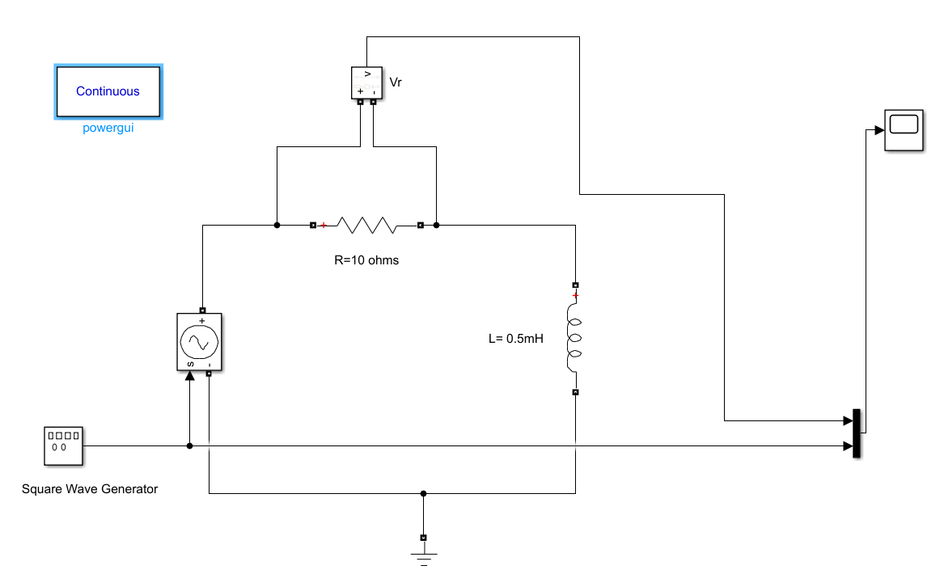

* R = 10 ohms
* L = 0.5mH
* Time constant (τ) = L/R == 5 X sec

OBSERVATIONS:

For RC Circuit:

Case I: Pulse Width tp=5τ= 5×sec

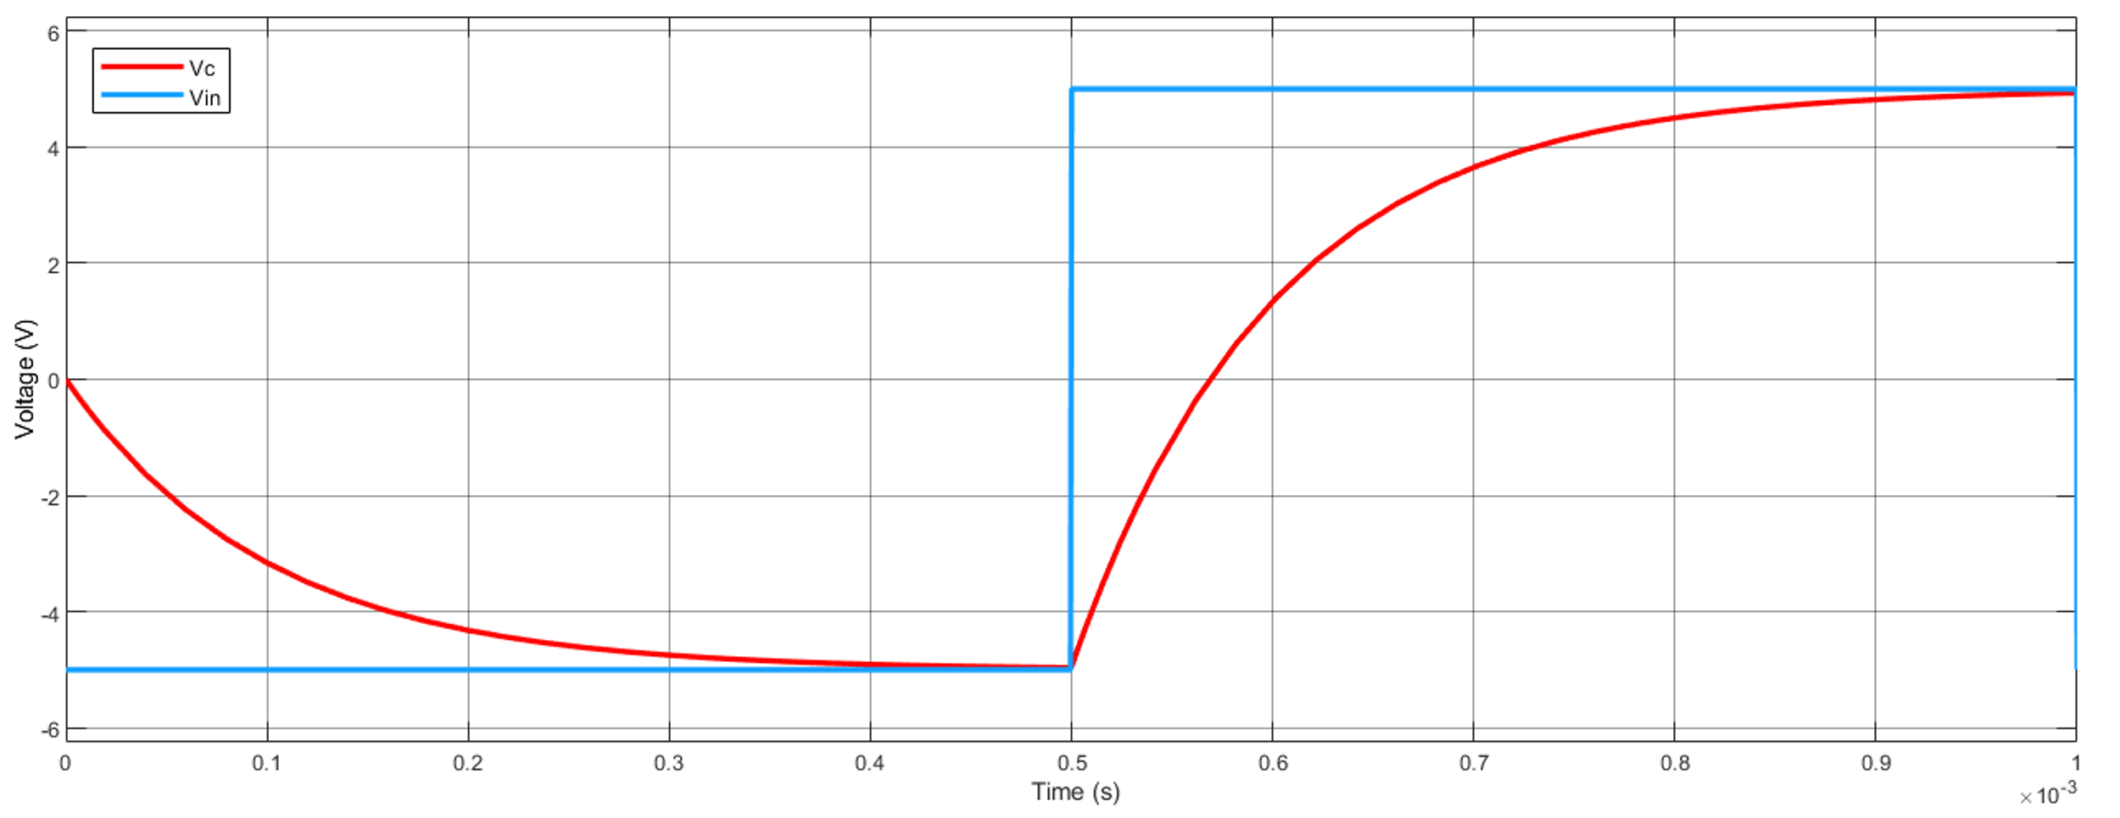

Case II: Pulse Width tp=10τ= 2.5×sec

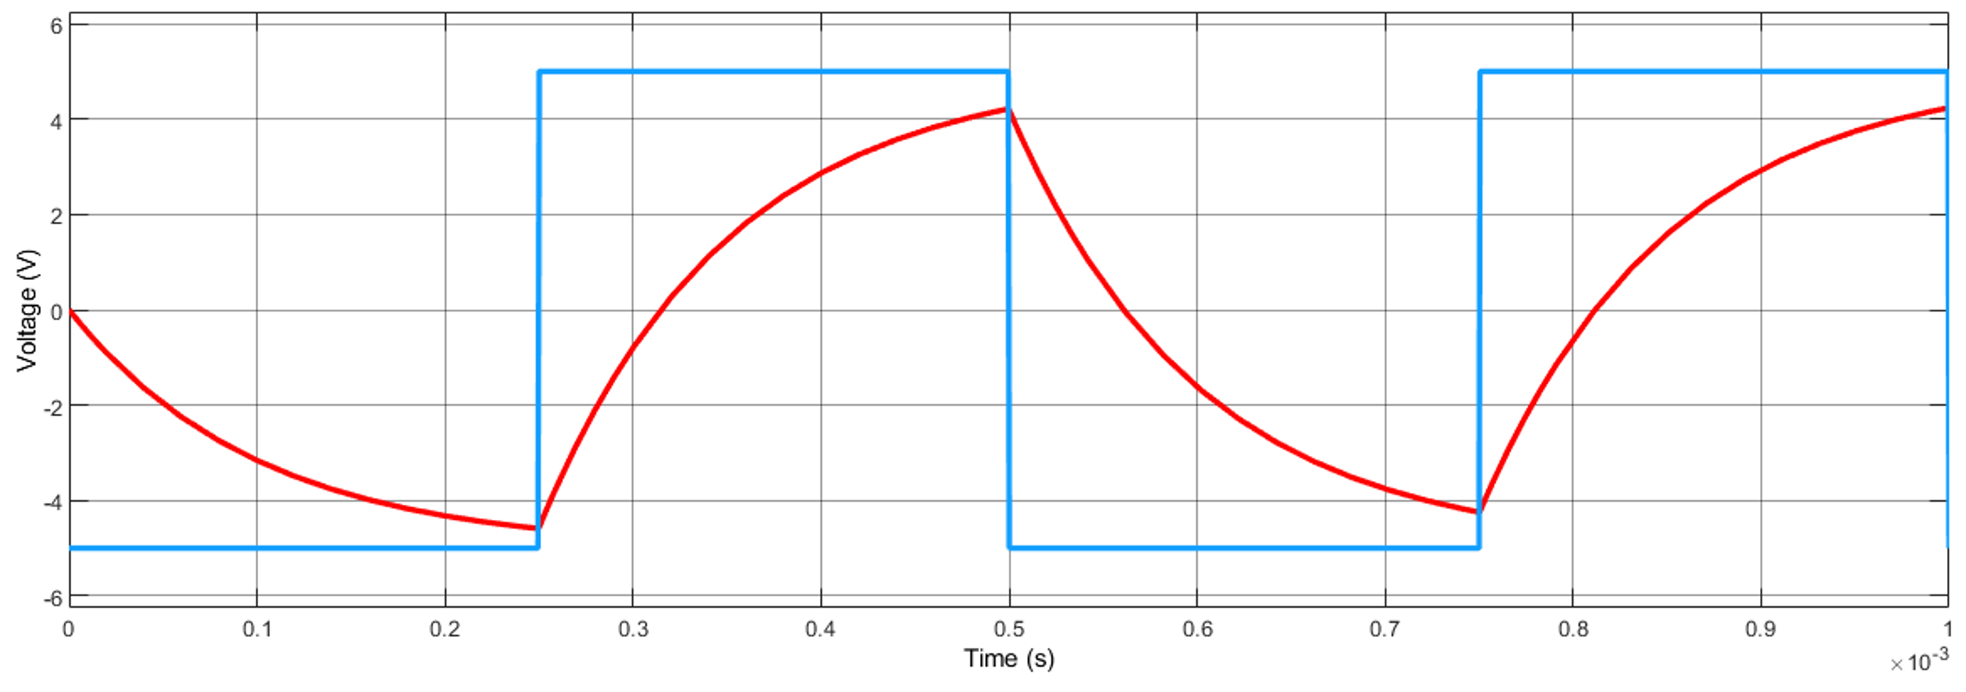

For RL Circuit:

Case I: Pulse Width tp=5τ= 25×sec

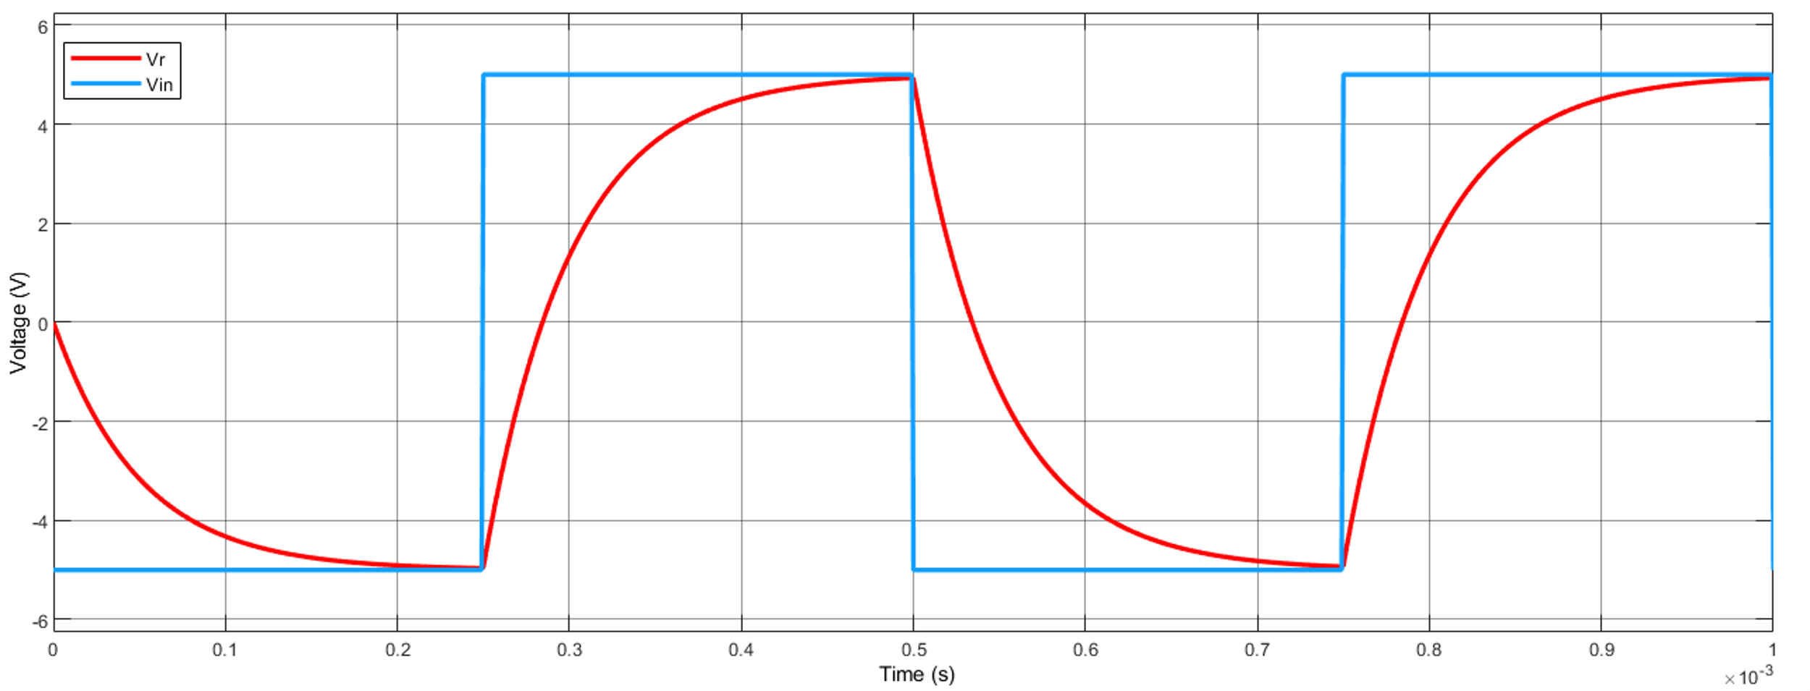

Case II: Pulse Width tp=2.5τ= 12.5×sec

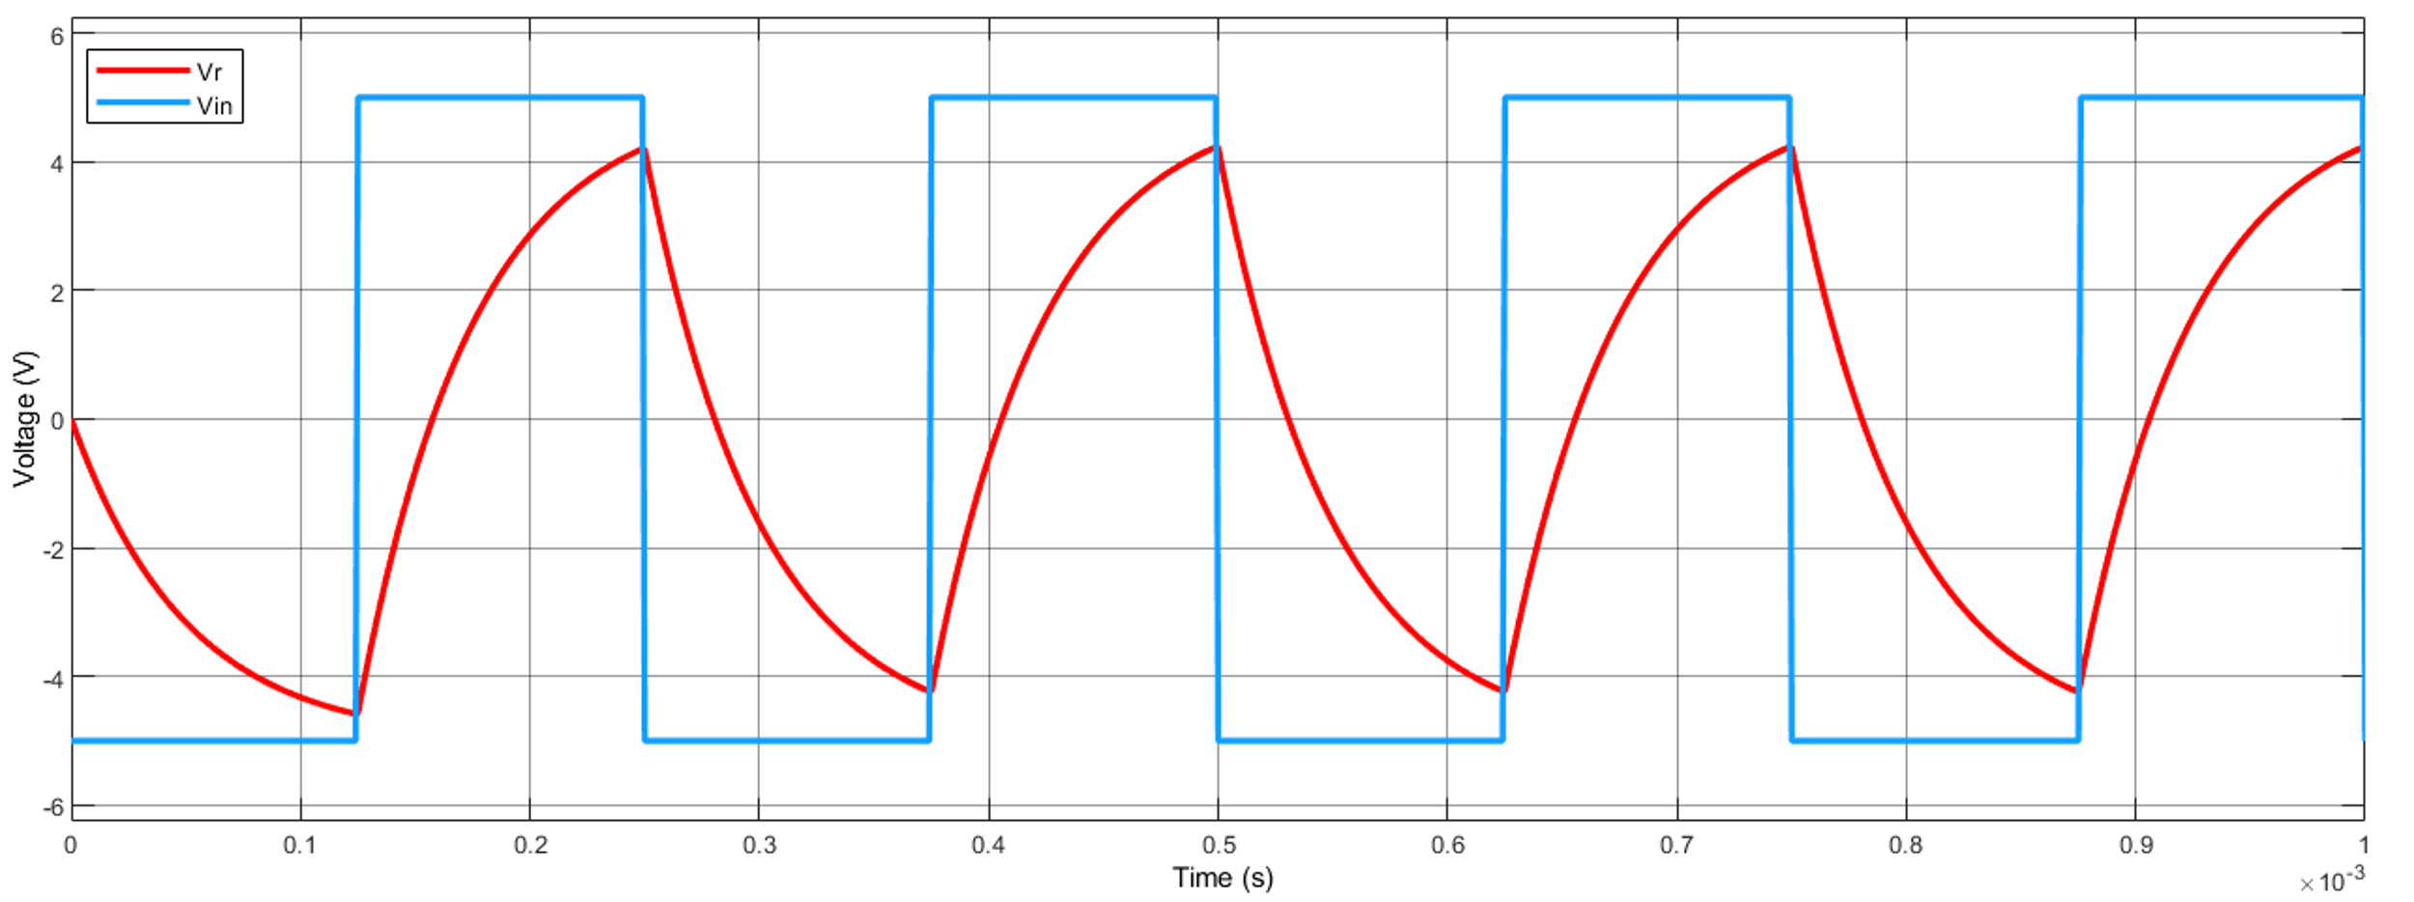

ANALYSIS:

We know that the steady state response is reached when the time elapsed is greater than 5τ, steady state is said to have been reached.

In the above simulations for RC and RL response to square wave, we have considered 2.5τ and 5τ. We see that for 2.5τ, the system could not reach steady state before the phase changes, for 5τ it almost reaches steady state.

**Experiment: 3**

**Title:** Transient response of RLC series circuit

**Objective:**

To design overdamped, under damped and critically damped series RLC circuit and observe their transient responses.

**Circuit Diagram:**

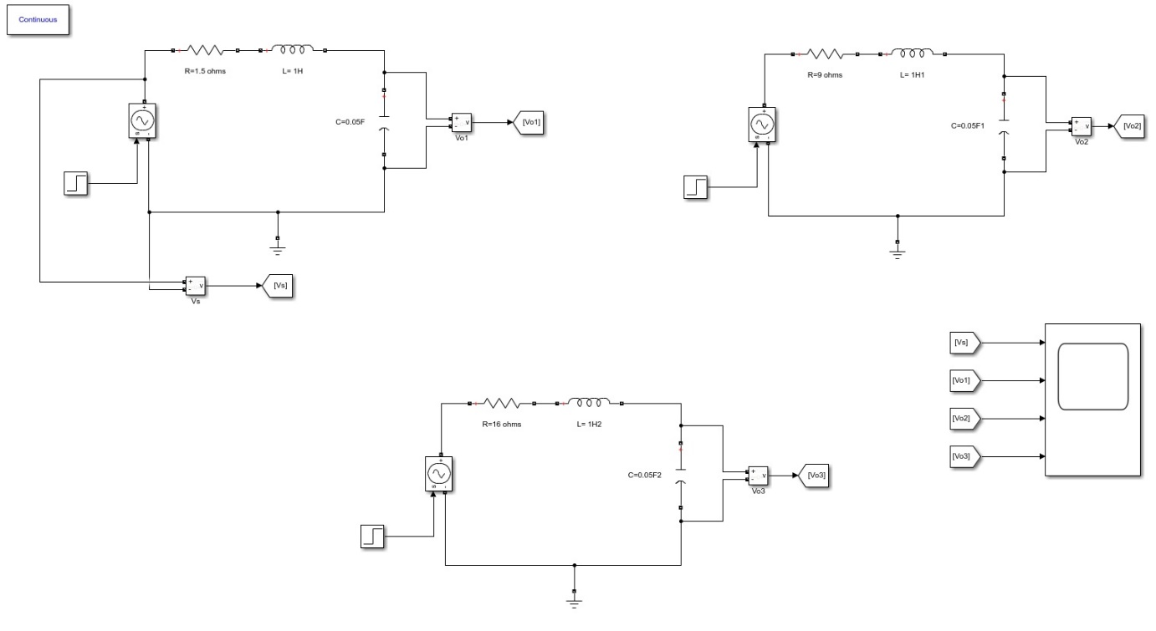

**Values for simulation:**

|  |  |  |  |
| --- | --- | --- | --- |
| **Parameters** | **Underdamped** | **Critically Damped** | **Overdamped** |
| **R** (Ω) | 1.5 | 9 | 16 |
| **L** (H) | 1 | 1 | 1 |
| **C** (F) | 0.05 | 0.05 | 0.05 |
| **α** (R/2L) | 0.75 | 4.5 | 8 |
| **ω0** (1/(LC)^0.5) (rad/sec) | 4.472 | 4.472 | 4.472 |
| Condition- | α <ω0 | α≈ω0 | α >ω0 |

**Simulation Results:**

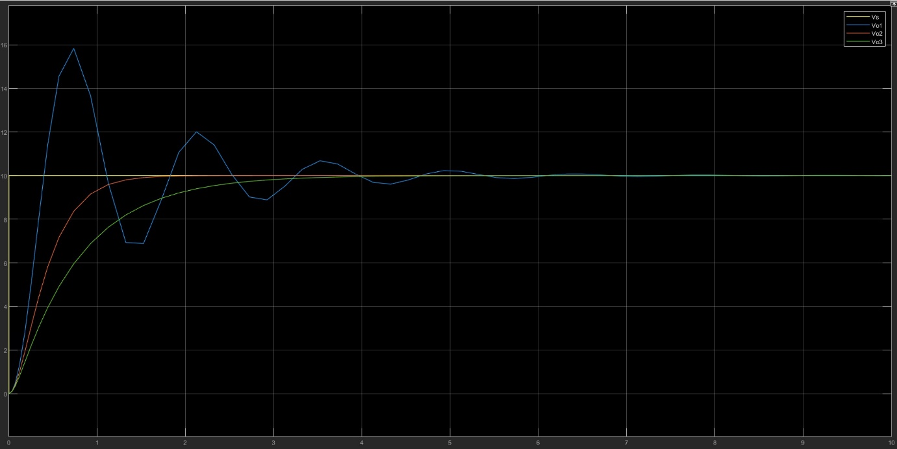

**Discussion:**

As the resistance of the series circuit increases then the value of α increases and the system is driven towards an overdamped response.

The frequency ω0 is called the natural frequency/ resonant frequency of the system.

The parameter α is called the damping rate and its relation to ω0 determines the behaviour of the response.

Experiment 4

Title

RL Steady State Simulation and determination of frequency response of High Pass RL filter.

Objective

To calculate the –

1) Cut-off frequency of the filter circuit

2) Stop-band of the filter circuit

Circuit Diagram

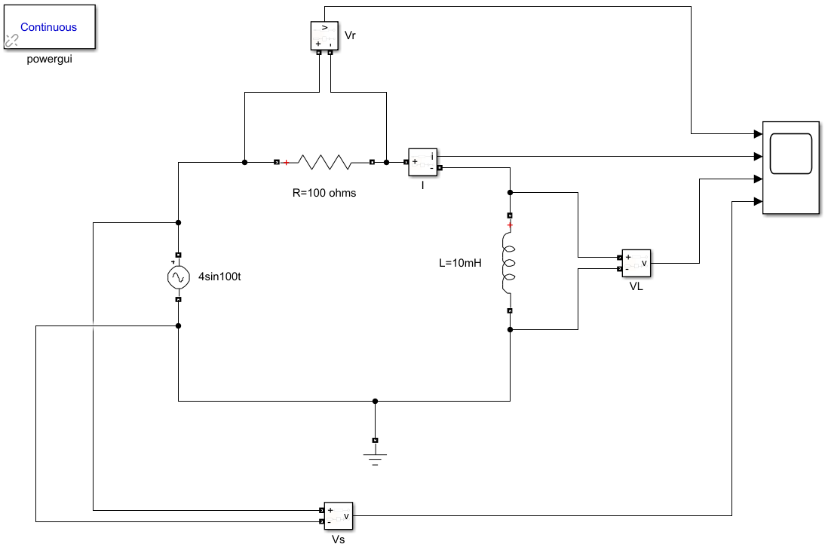

* R = 100 ohms, L = 10 mH
* Time Constant = L/R = 0.1 ms
* Transfer Function = S/(S + R/L) = S/(S + 104)
* Cut-off Frequency, fc = R/2πL = 1591.55 Hz

**Analysis**

When we excite the system with a normal frequency of 50Hz or 60Hz we find that almost the entire voltage appears across the resistance and almost no output voltage appears across the inductor. So, the inductor block voltage at low frequencies as shown in the figure below.

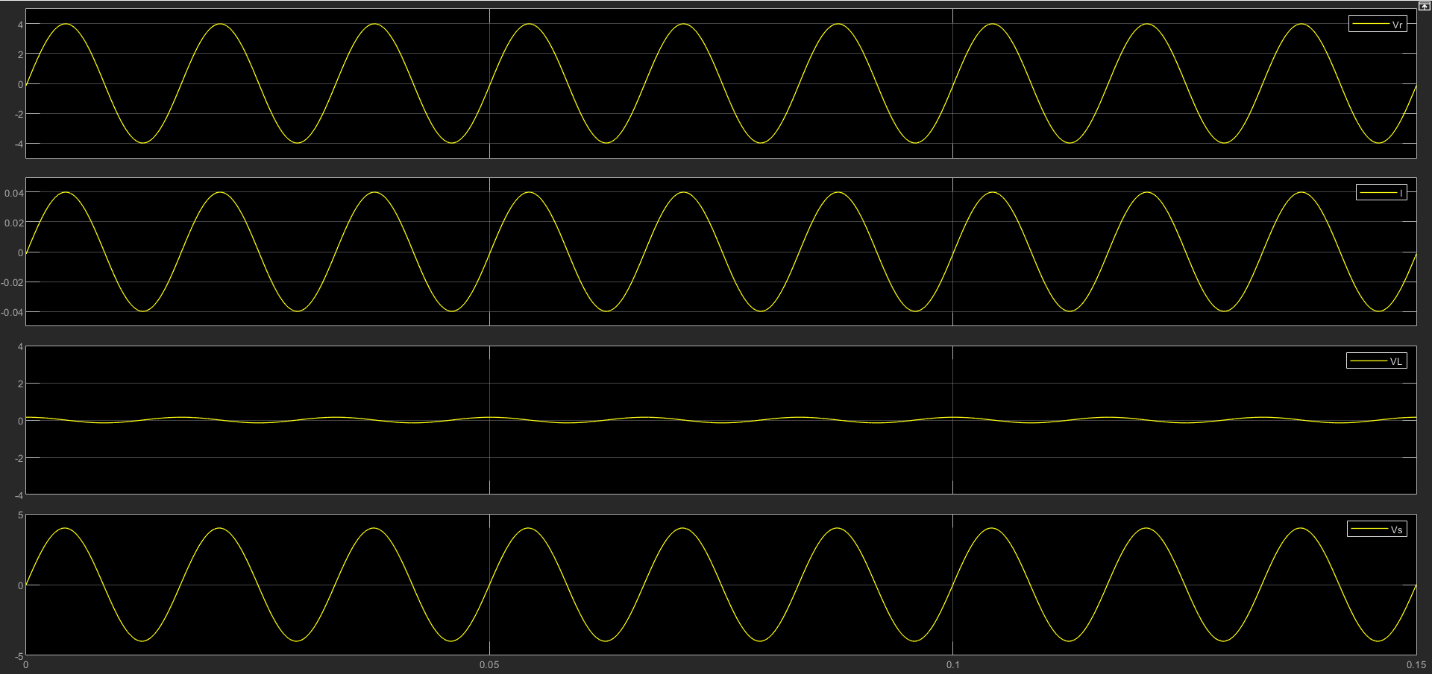

*Figure 1: Plot 1 - Vr, Plot 2 - I , Plot 3 – VL , Plot 4 – Vs (At 60 Hz)*

However, as we increase the frequency (to a higher value) we find that voltage across the inductor increases. This is because the series RL circuit acts as a high pass filter. It allows higher frequencies to pass through and it blocks lower frequencies.

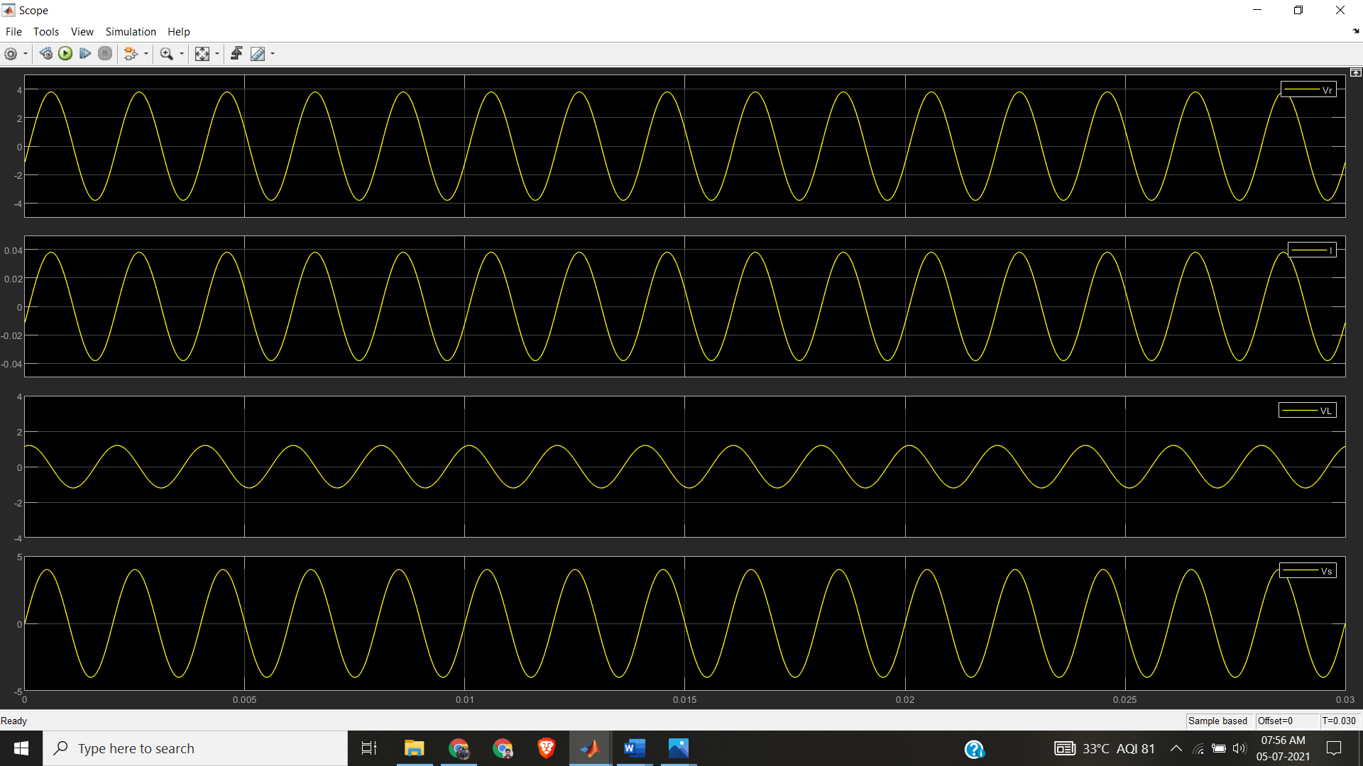

*Figure 2: Plot 1 - Vr, Plot 2 - I , Plot 3 - VL , Plot 4 – Vs ( at 500Hz)*

Also, we observe that at very high frequencies (frequencies higher than cut-off frequencies) almost entire output voltage appears across the inductor and voltage across the resistor decreases as shown in the figure below.

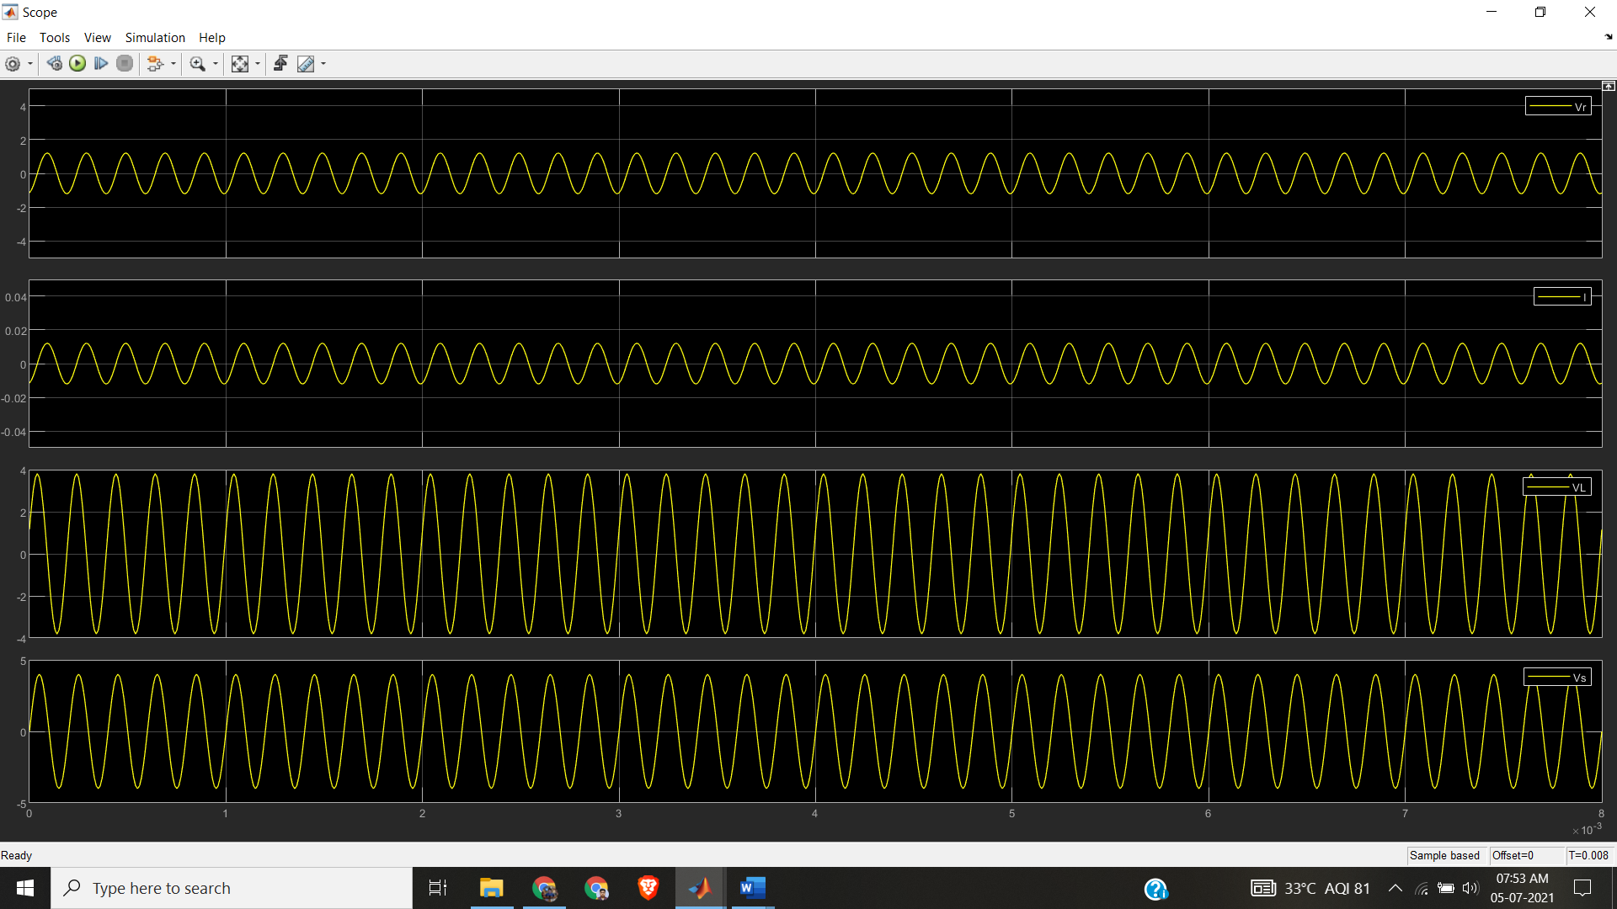

*Figure 3: Plot 1 - Vr, Plot 2 - I , Plot 3 - Vc , Plot 4 – Vs ( at 5000 Hz )*

The exact cut off frequency can be found out from the frequency response of the circuit. Bode plot of the same is given below.

Bode Plot

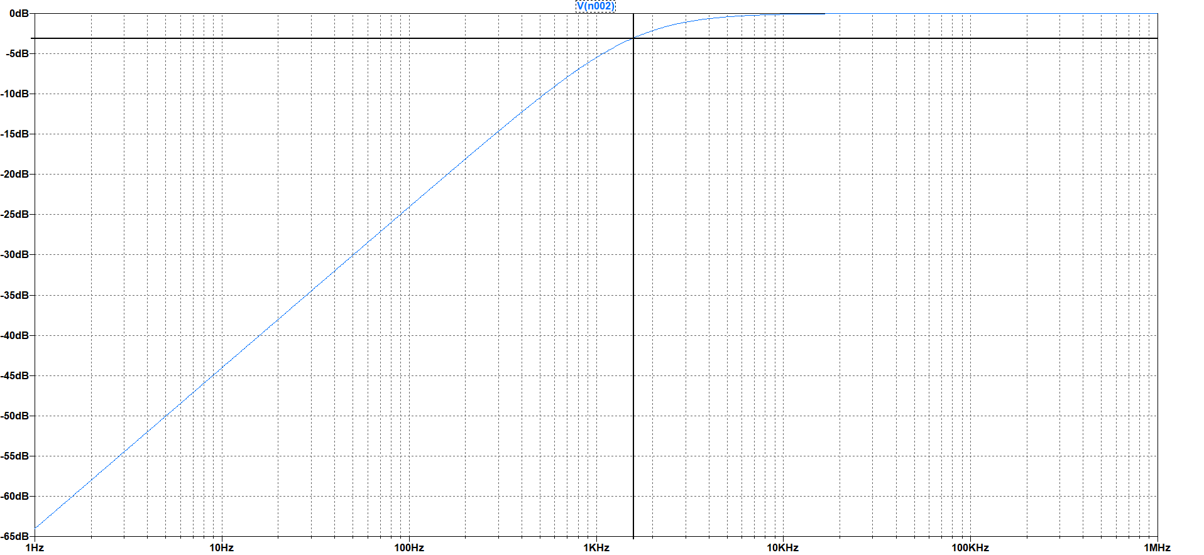

Gain (dB) : -3

Frequency (Hz) : 1592

- 3 dB

Cut-off frequency

Stop Band

Pass Band

Gain (dB)

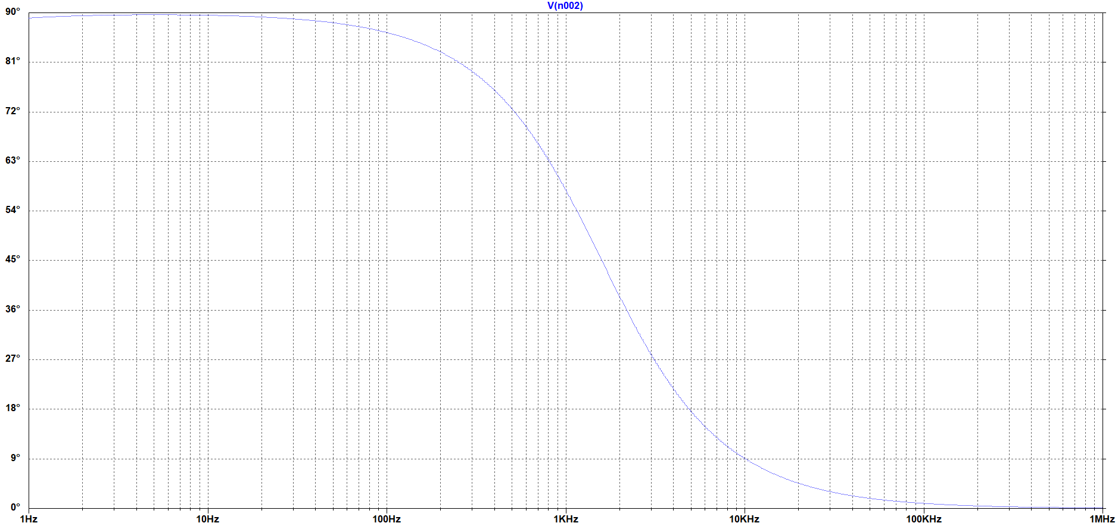

Phase (deg)

From the plot the -3db gain occurs at 1592 Hz. Hence its cut off frequency is 1592 Hz. And it’s stop band is also 1592 Hz.

Title

RC Steady State Simulation

Objective

To calculate the bandwidth of the network

Circuit Diagram

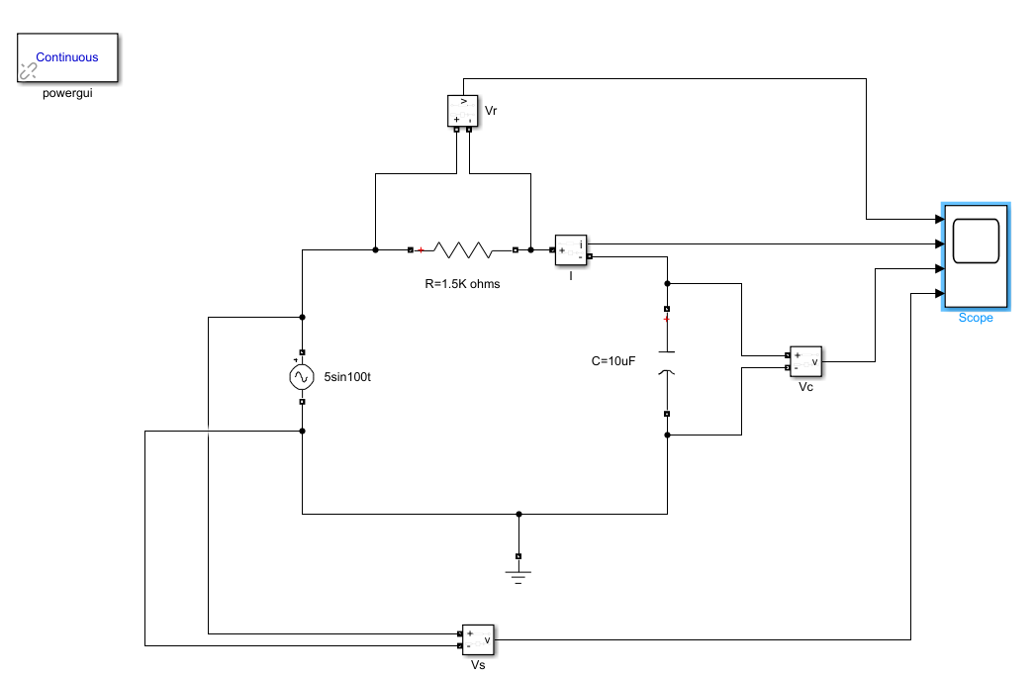

* R = 1500 ohms, C = 10^-5 F
* Time Constant = RC = 0.0150s
* Transfer Function = 1/ (1 + RCs) = 1/(1+0.015s)
* Corner Frequency = 1/0.015 = 66.67rad/s = 10.6 Hz

Analysis

When we excite the system with a normal frequency of 15Hz we find that almost the entire voltage appears across the capacitor. It doesn’t block any voltage as shown in the figure below.

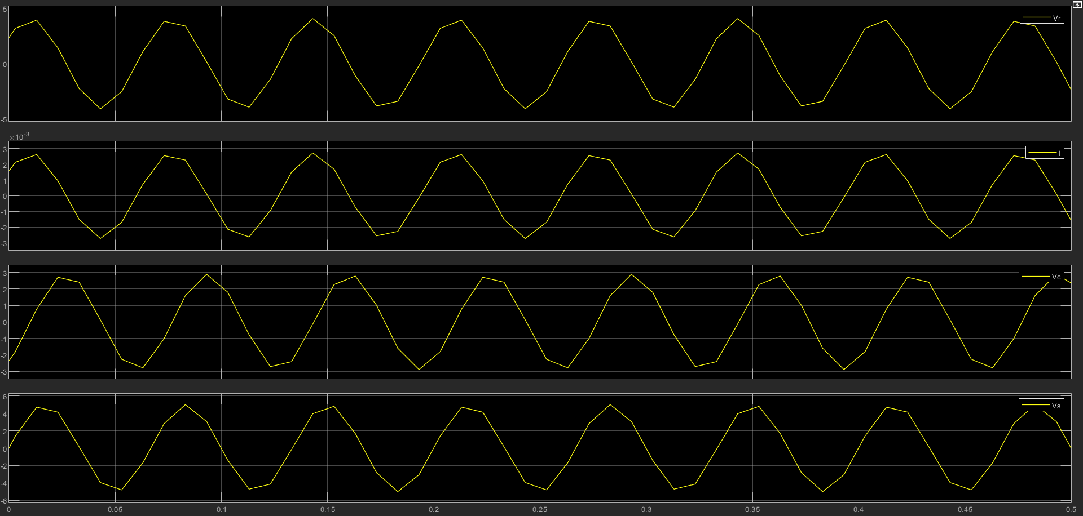

*Figure 4: Plot 1 - Vr, Plot 2 - I , Plot 3 - Vc , Plot 4 – Vs (At 15 Hz)*

However, as we increase the frequency to (a very high value) we find that no voltage appears across the capacitor. This is because the series RC circuit acts as a low pass filter. It allows lower frequencies to pass through and it blocks higher frequencies.

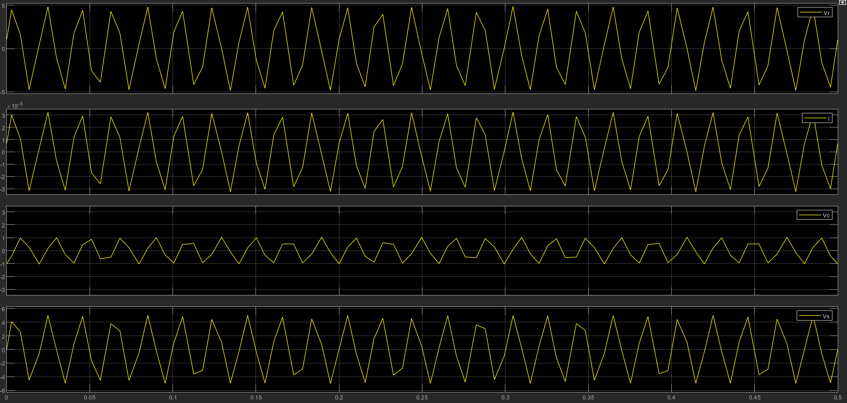

*Figure 5: Plot 1 - Vr, Plot 2 - I , Plot 3 - Vc , Plot 4 – Vs ( at 50Hz)*

Also, we observe that at very high frequencies almost no output voltage appears across the capacitor as shown in the figure below.

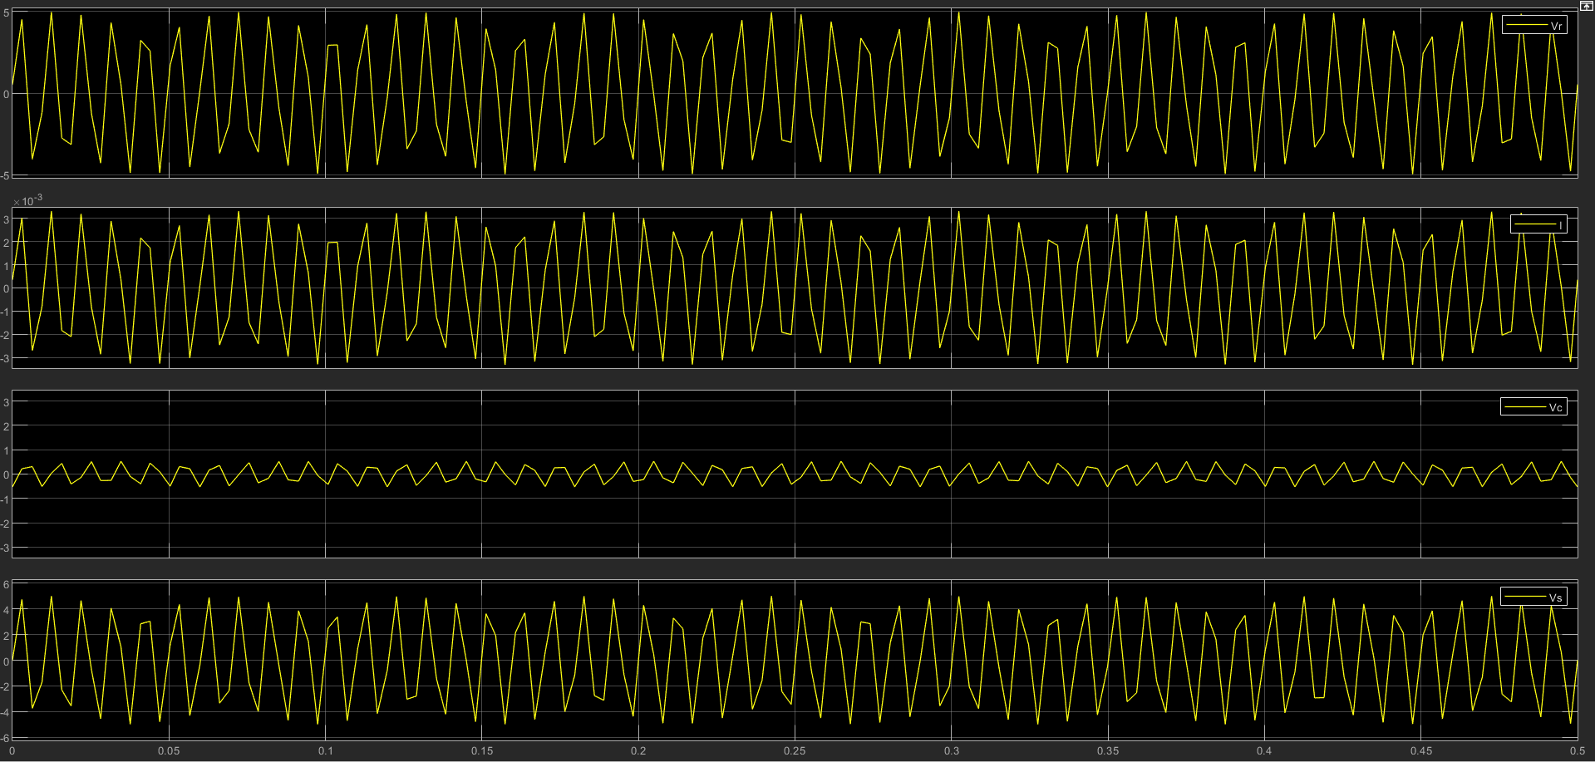

*Figure 6: Plot 1 - Vr, Plot 2 - I , Plot 3 - Vc , Plot 4 – Vs ( at 100 Hz )*

The exact cut off frequency can be found out from the frequency response of the circuit and drawing a bode plot below.

Bode Plot

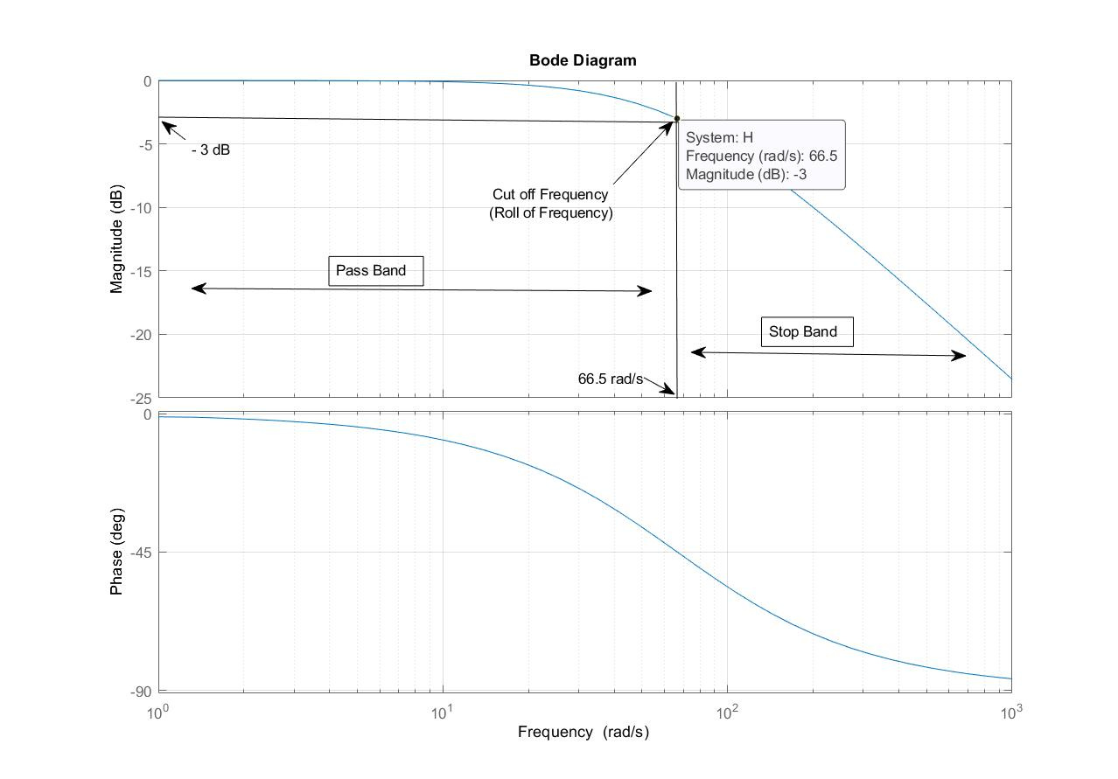As is evident from the plot the -3db gain occurs at 66.5 rad/s. Hence its cut off frequency is 66.5 rad/s = 10.58 Hz. Its bandwidth is also 10.58 Hz.

# **Title**

Steady State Response of a series RLC circuit and determination of its frequency response.

# **Objective**

1) To observe amplitude and phase change in an RLC circuit under a sinusoidal forcing function.

2) To calculate the resonant frequency of the circuit.

# **Circuit Diagram**

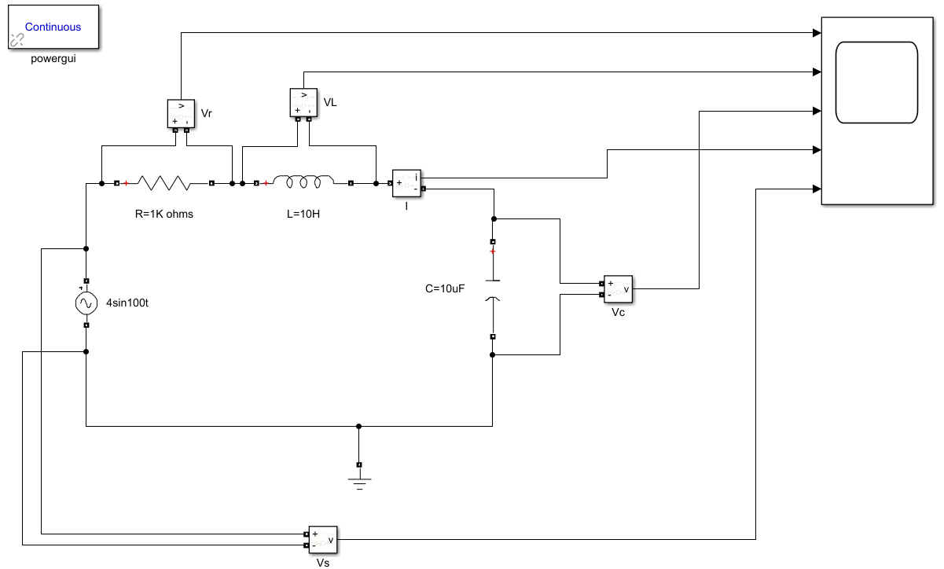

* R = 1000 ohms, L = 10 H and C = 10uF
* Source voltage amplitude, Vs = 4 V
* Resonant Frequency, f0 = = 15.915 Hz

# **Analysis**

We can see voltage across the resistor, Vr is in phase with source voltage Vs. Voltage across the inductor, VL is 90° leading to the source voltage and voltage across capacitor, VC is 90° lagging behind the source voltage.

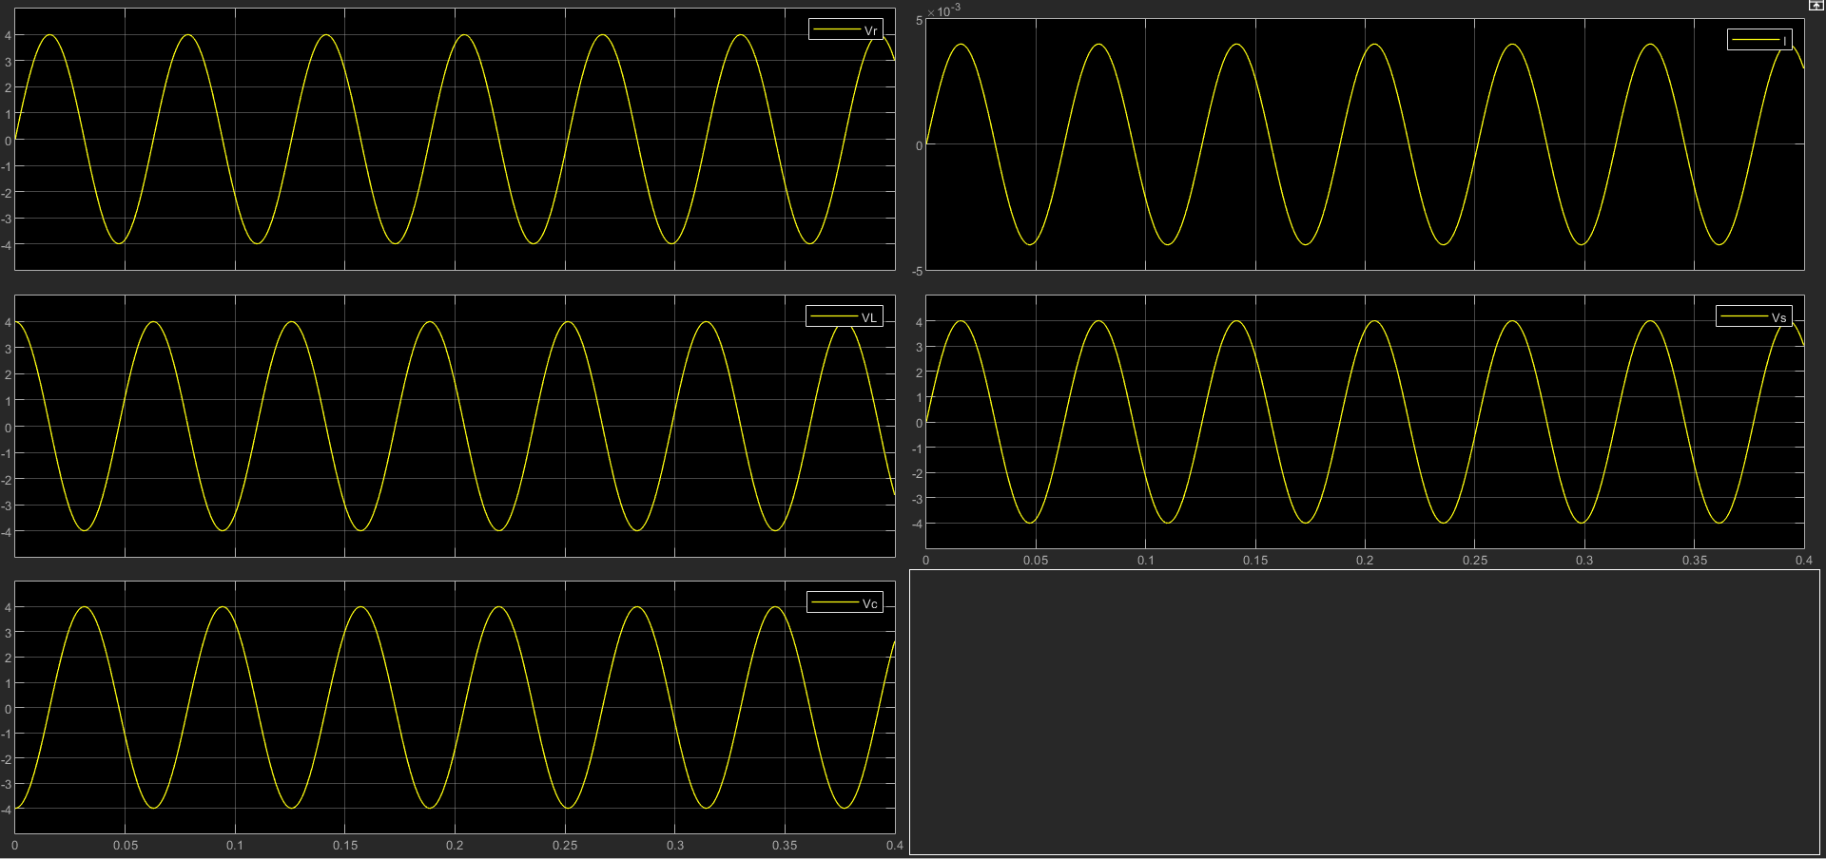

Figure 7: Plot 1 - Vr, Plot 2 - VL, Plot 3 – VC, Plot 4 – I, Plot 5 – Vs (At 15.915 Hz)

In the given figure-1, as the source frequency is same as the resonant frequency the circuit is in resonance. For this reason, the current and the voltage are in phase.

But if we apply frequency lower than the resonant frequency current leads the source voltage. So, at this condition, behaviour of the circuit is Capacitive, shown in the figure-2 given below.

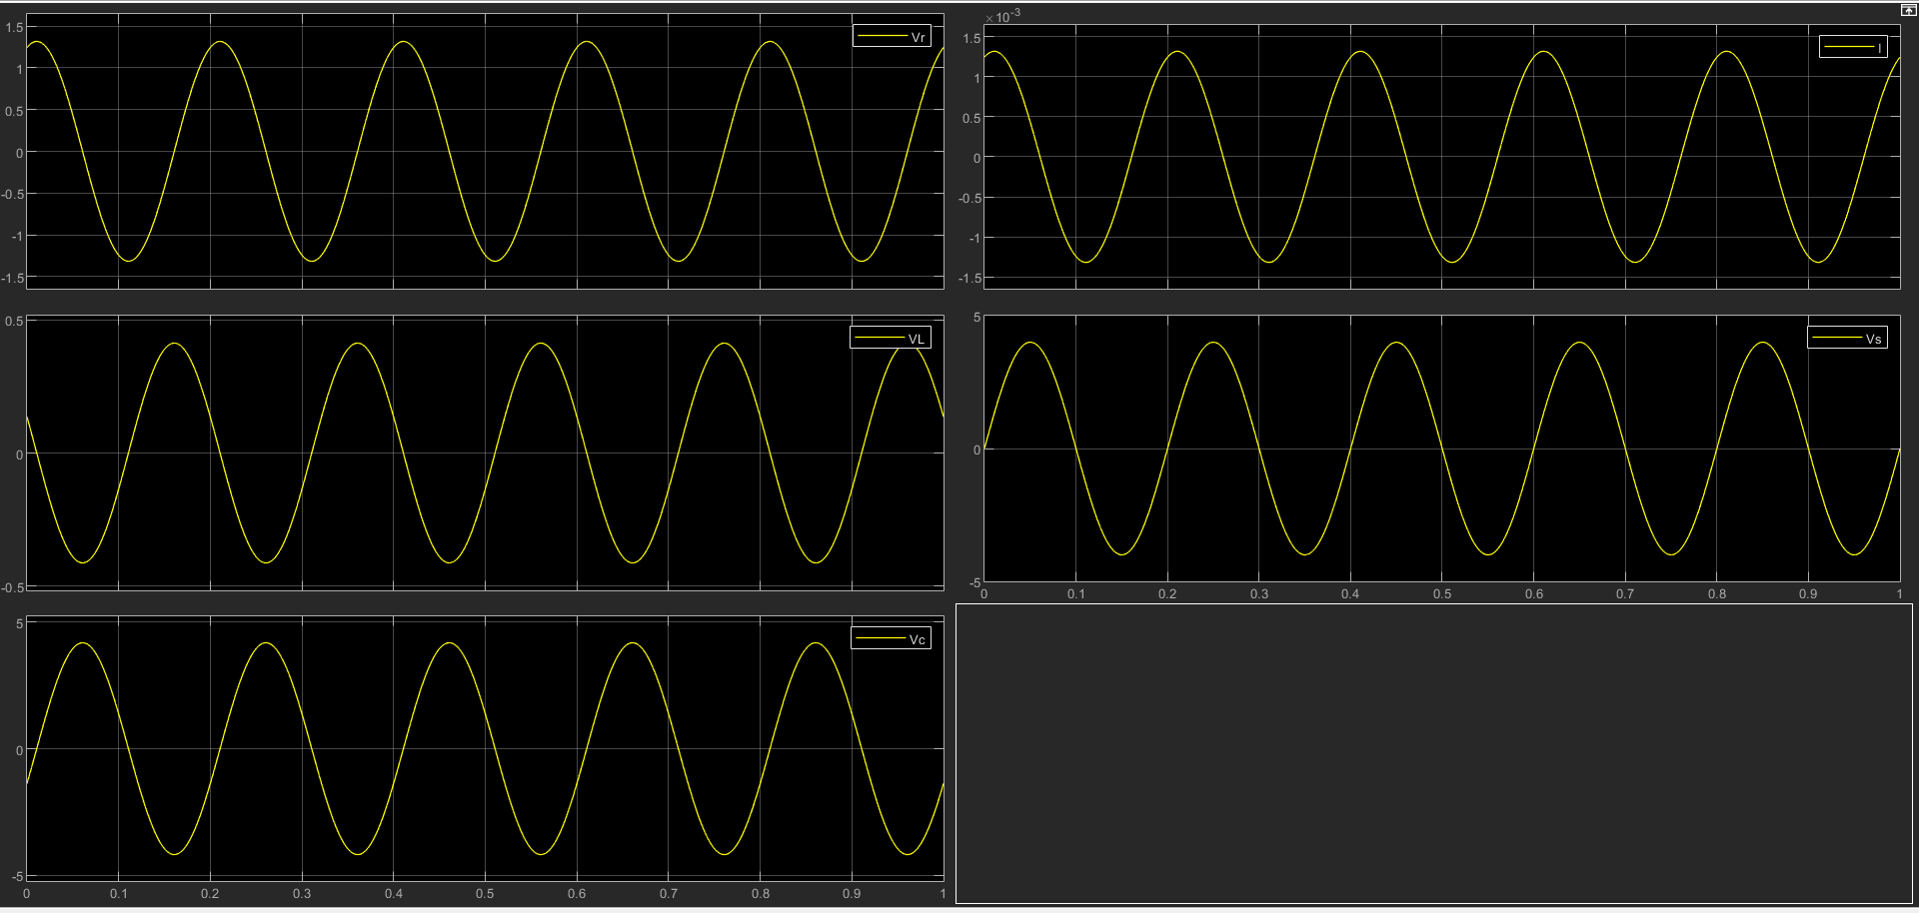

Figure 2: Plot 1 - Vr, Plot 2 - VL, Plot 3 – VC, Plot 4 – I, Plot 5 – Vs (At 5 Hz)

Now, if we apply frequency higher than the resonant frequency current lags behind the source voltage. So, at this condition, behaviour of the circuit is inductive, shown in the figure-3 given below.

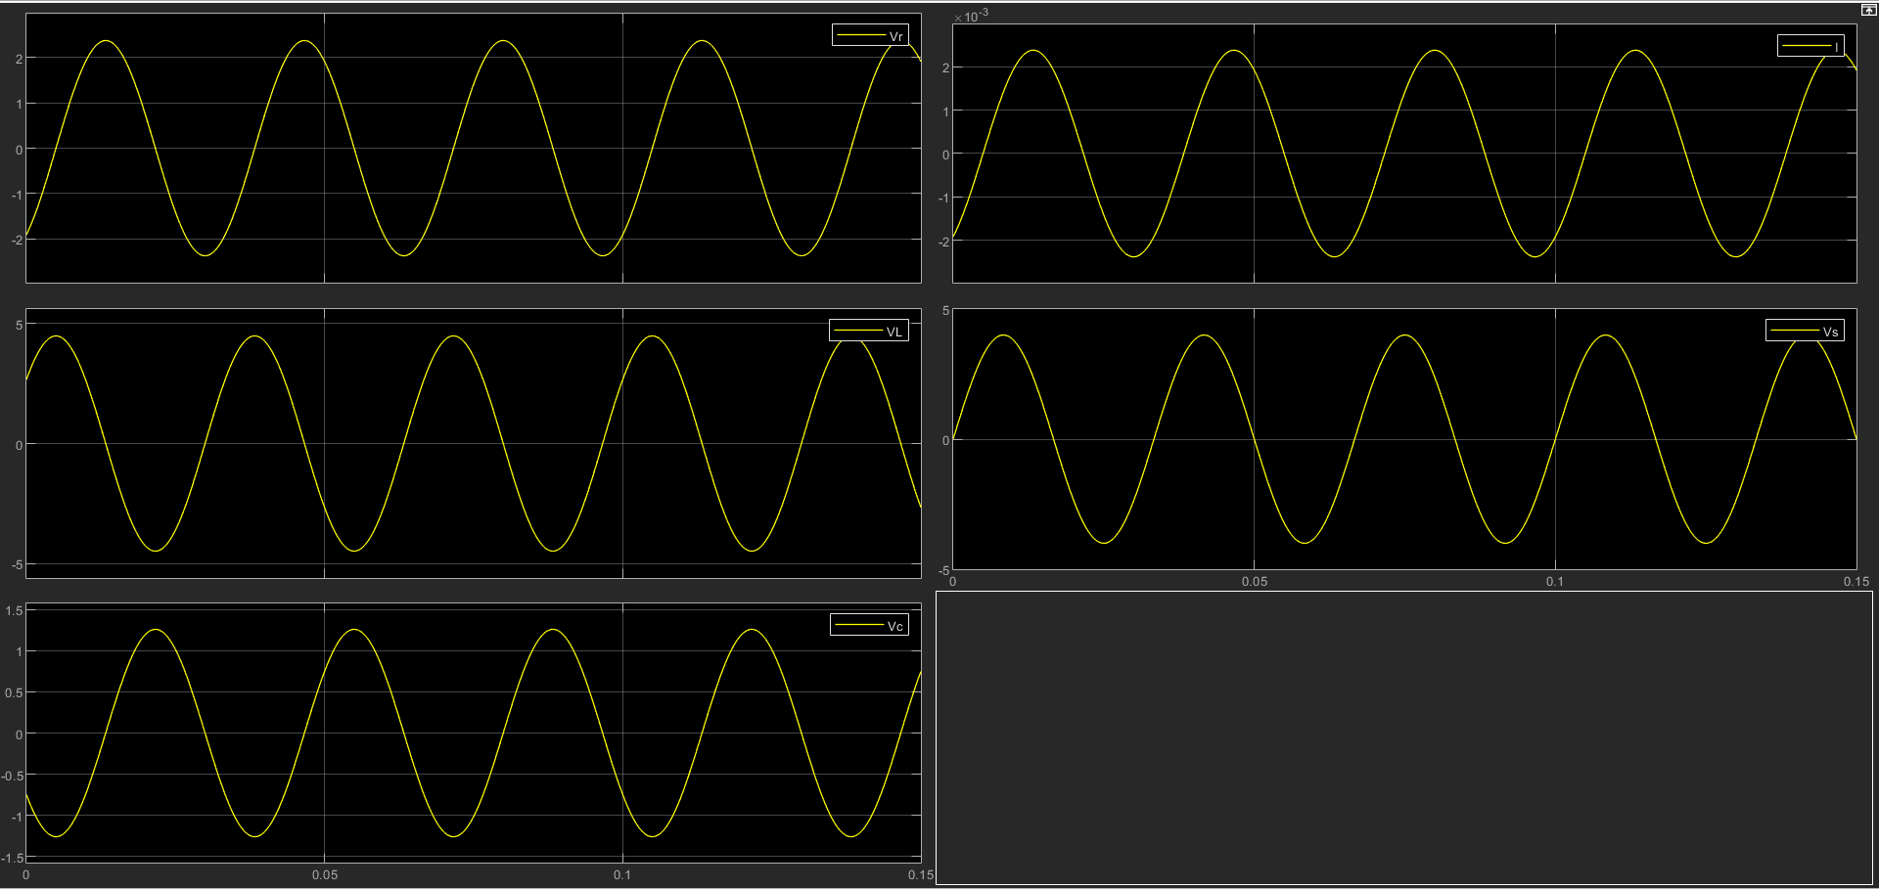

Figure 3: Plot 1 - Vr, Plot 2 - VL, Plot 3 – VC, Plot 4 – I, Plot 5 – Vs (At 30 Hz)

**Frequency Response**

Frequency response of the circuit is given below, from where we can find the resonant frequency.

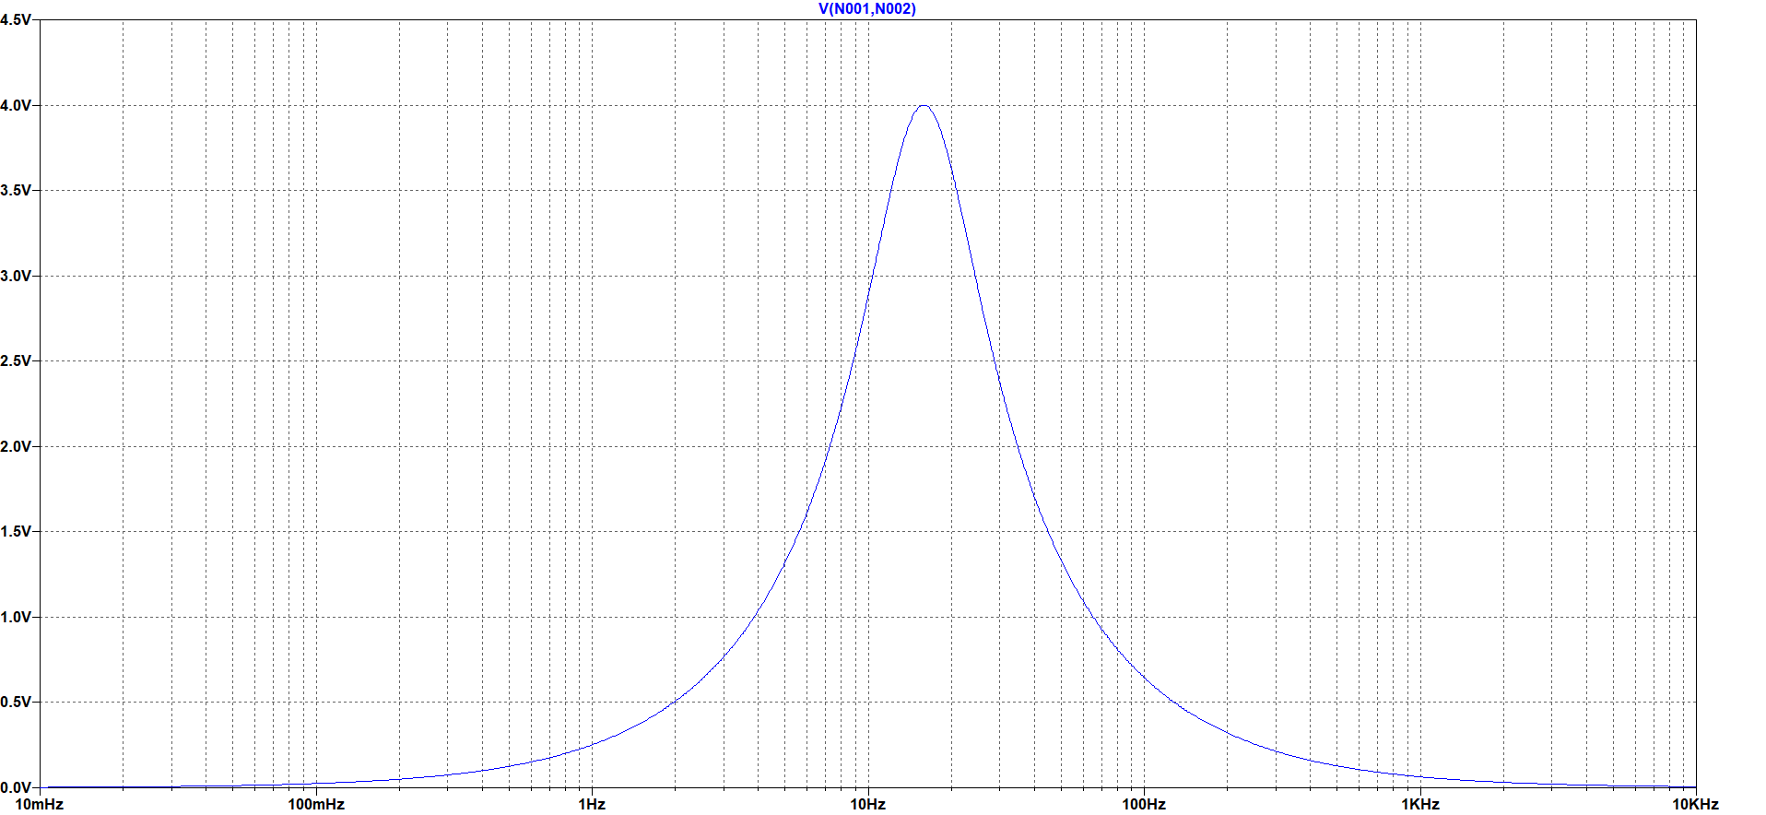

Vo = 4 V

Frequency = 15.915 Hz

f0

Resonant frequency of the circuit is 15.915 Hz.